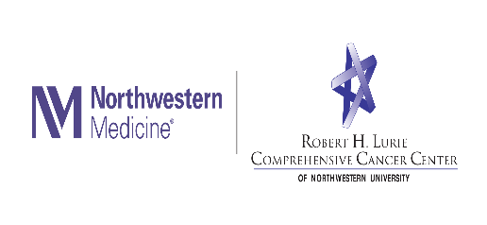

Postdoctoral Research Fellowship
Behavioral and Psychosocial Topics in Clinical Genomics

The Department of Medical Social Sciences at the Northwestern University Feinberg School of Medicine (NU/FSM) is seeking strong applicants for a new postdoctoral fellowship position. This position will provide Fellow with an outstanding mentored research and training experience, with the goal of supporting the Fellow’s growth into an independent leader in behavioral and psychosocial genomics research. The Department of Medical Social Sciences provides a unique scientific home for applied researchers who integrate biomedical and social science approaches to improve health and health care delivery (www.mss.northwestern.edu). Its rich resources include biostatistical and health informatics cores, expertise in assessment methods, and collaborative relationships across Northwestern’s biomedical and life sciences campuses. The Fellow will also have access to outstanding resources available at Northwestern University, the Feinberg School of Medicine, and the Robert H. Lurie Comprehensive Cancer Center. The Northwestern University Office of Postdoctoral Affairs offers connections with a large community of Fellows, professional development, and career advising.

The Fellow will be mentored by Dr. Christine Rini, who is one of the principal investigators of a study of clinical diagnostic exome sequencing called NCGENES, which is being conducted at the University of North Carolina at Chapel Hill (UNC). Consequently, in addition to the resources described above, the Fellow will have the opportunity to build collaborations with the NCGENES study’s interdisciplinary research team at UNC. Because NCGENES is part of an NIH-funded consortium of research sites studying clinical sequencing, it will also be possible to become involved in collaborative projects with colleagues from across consortium sites. The Fellow will develop an independent line of research using a rich dataset from the first NCGENES study, which focused on diagnostic exome sequencing in adults and children with suspected genetic disorders, and/or the ongoing NCGENES 2 study, which is investigating diagnostic sequencing in a highly diverse population of families of children with suspected genetic disorders. Some possible topics include patient decision making, understanding of genomic sequencing and the results it produces, responses to receiving genomic sequencing findings, and use of genomic sequencing in underserved families, but other topics are possible, and the Fellow may also plan new data collection. The Fellow will gain experience in grant writing, data analyses, and manuscript writing.

Candidates are required to: (1) possess a PhD or other doctoral-level degree in psychology, public health, or a similar behavioral/social science discipline or be enrolled in an accredited doctoral degree program and fulfill all degree requirements prior to program entry, and (2) be a citizen or permanent resident of the United States at the time of application. Minority applicants are encouraged. This position is supported in part by an NIH U01 research grant. It is a full-time appointment, initially for 1 year and renewable for up to 2 years. Salary and benefits are highly competitive. To apply, please send a cover letter, a curriculum vitae, and a statement describing research interests and experience to Dr. Christine Rini at Christine.rini@northwestern.edu.

Northwestern University is an Equal Opportunity, Affirmative Action Employer of all protected classes including veterans and individuals with disabilities.

